Partitioned Table

All scripts are in the same directory as this document

(V2__Create.sql, V2.1__CreatePartitioned.sql, V3__Insert.sql, heap.sql, hub.sql)  
  
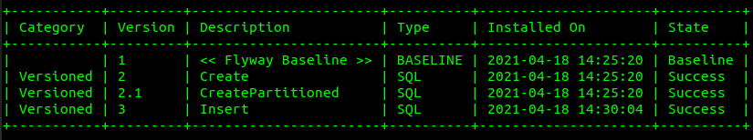

pgbench -T 300 -c 1 -f

1. latency = 0.201 ms tps = 4986.003107 script - heap.sql
2. latency = 0.214 ms tps = 4673.550528 script - hub.sql

Distribution of amounts of data for all partitioned tables

